- Which of the following is not electromagnetic radiation?
- Radio Waves
- Light
- Infrared radiation
- X-rays
- Acoustic waves
- Optical fibers have minimum loss near 1.5 micrometers. What is the frequency that corresponds to that wavelength?
- 200 MHz
- 20 GHz
- 200 GHz
- 20 THz
- 200 THz
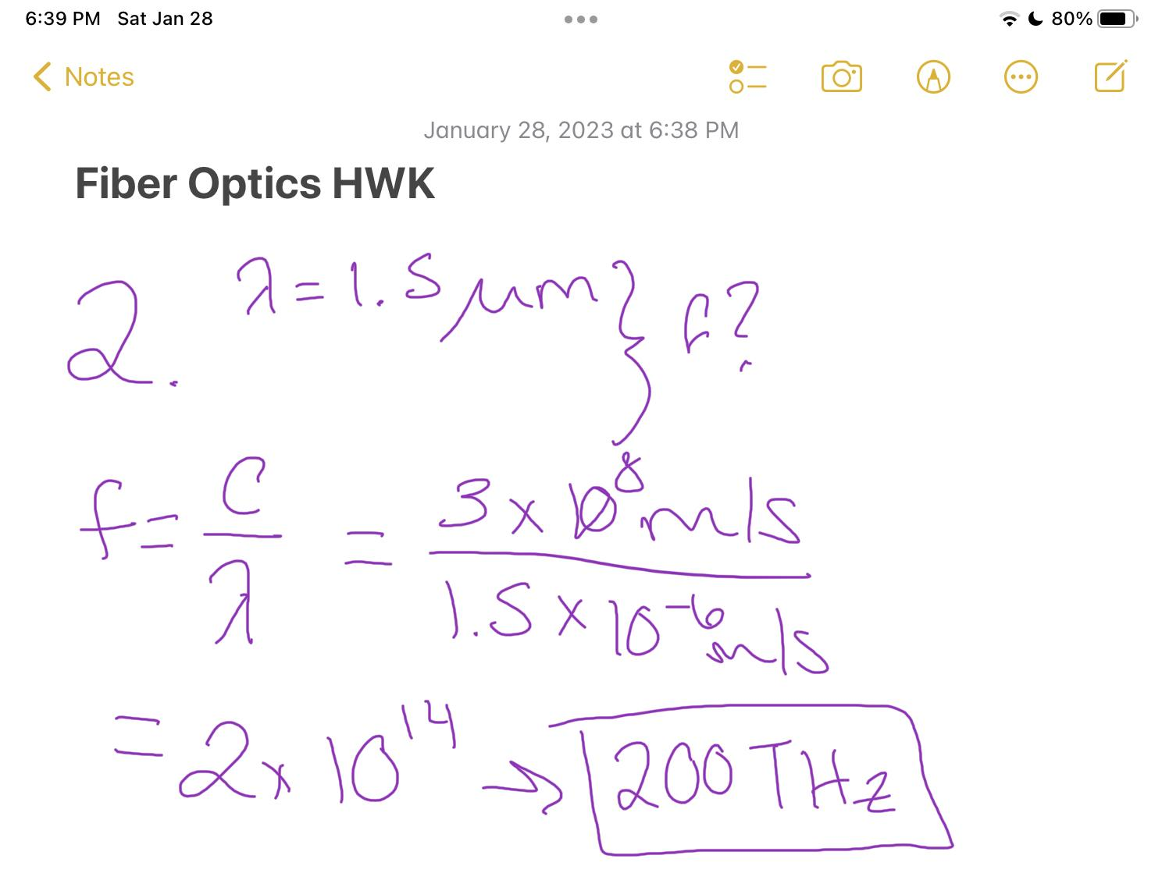
- An electron-volt is the energy needed to move an electron across a potential of 1 V. Suppose you could convert all the energy from moving an electron across a potential of 1.5 V into a photon. What would its wavelength be?
- 0.417 micrometers
- 0.5 micrometers
- 0.827 micrometers
- 1.21 micrometers
- 1.2399 micrometers
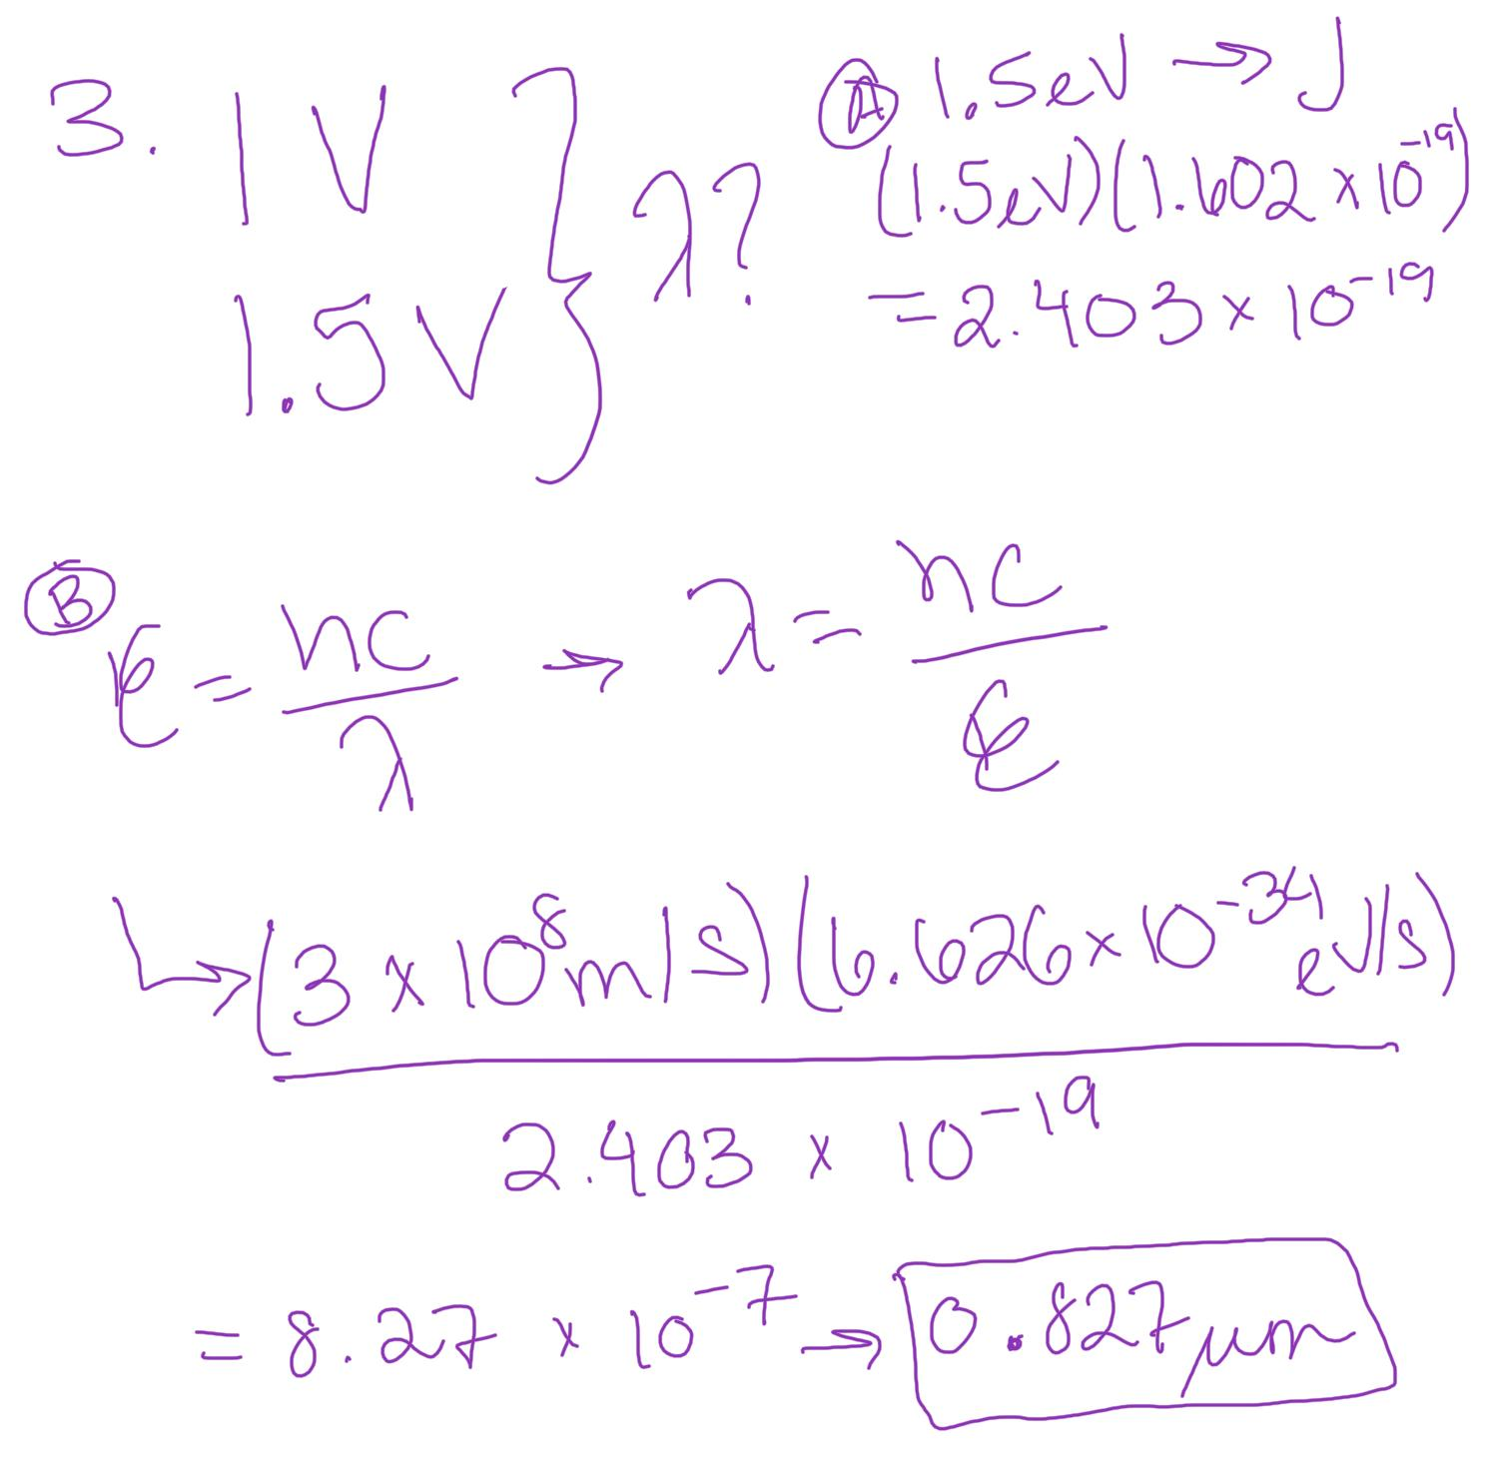
4. Light that passes from air into glass is
- Reflected
- Refracted
- Absorbed
- Scattered
5. Light is confined within the core of a
simple clad optical fiber by
- Refraction
- Total internal reflection at the outer edge of the cladding
- Total internal reflection at the core-cladding boundary
- Reflection from the fiber’s plastic coating
6. An optical fiber has a core with
refractive index of 1.52 and a cladding
with index of 1.45. Its number aperture
is
- 0.15
- 0.20
- 0.35
- 0.46
- 0.70
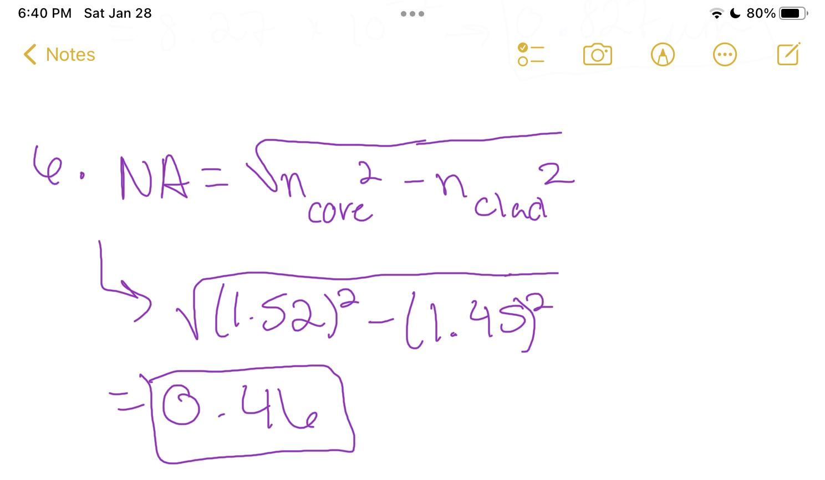
7. Zircon has a refractive index of 2.1.
What is the critical angle for total
internal reflection in air?
- 8 degrees
- 25 degrees
- 32 degrees
- 42 degrees
- 62 degrees
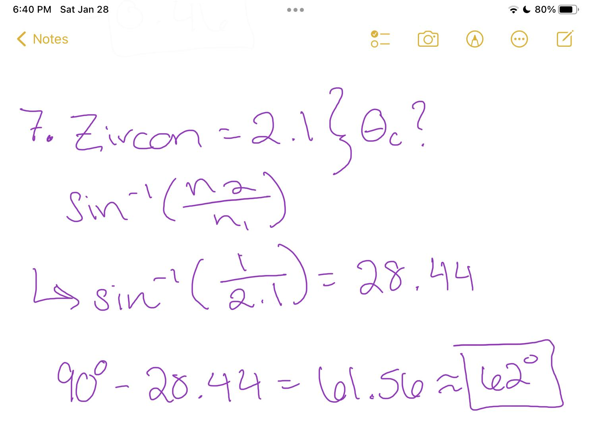
8. The output of a 20-km fiber with
attenuation of 0.5 dB/km is 0.005 mW.
What is the input power to the fiber?
- 0.5 mW
- 0.1 mW
- 0.05 mW
- 0.03 mW
- 0.01 mW
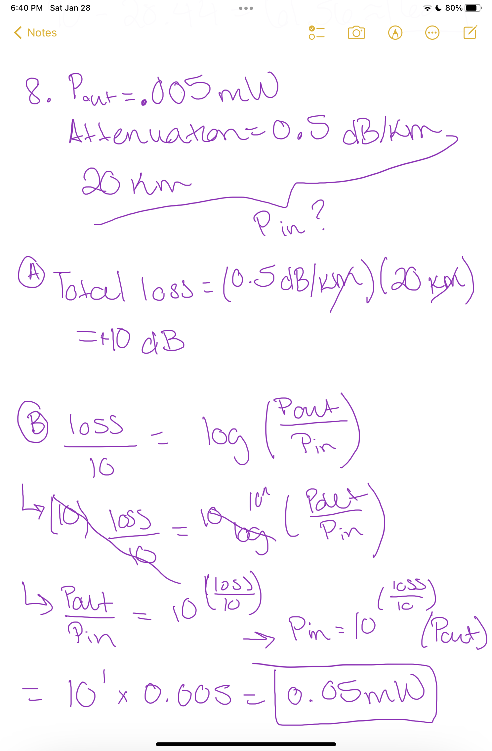
9. What fraction of the input power
remains after light travels through 100
km of fiber with 0.3 dB/km attenuation?
- 0.1%
- 0.5%
- 1%
- 5%
- 10%
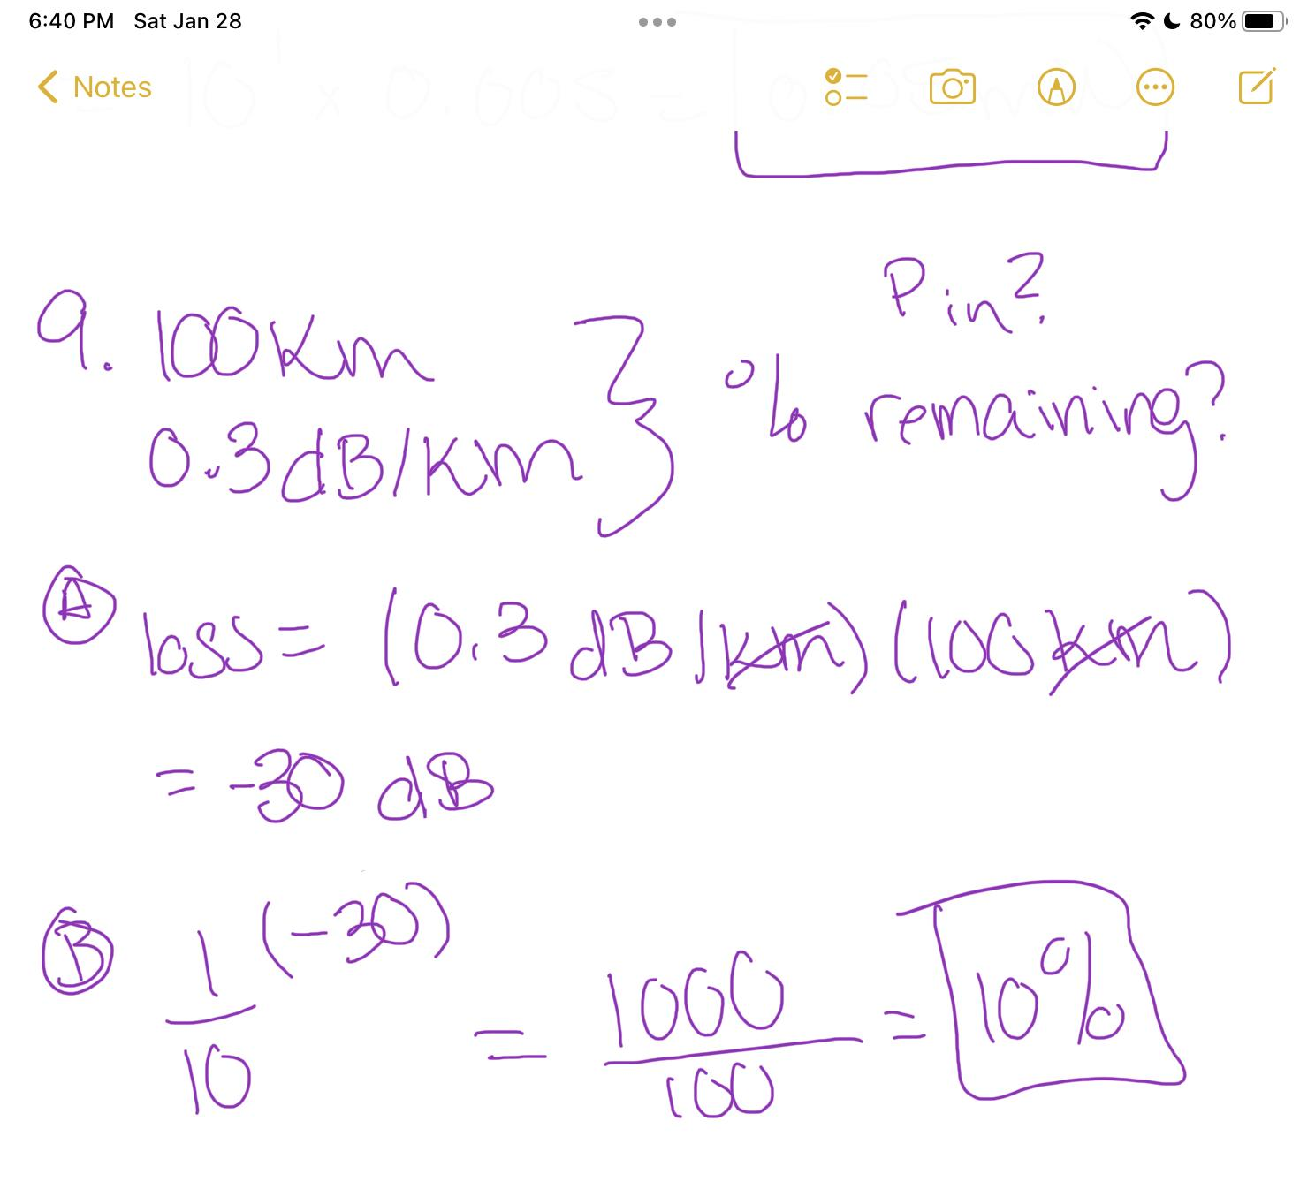
10. If a 1 cm glass plate transmits 90% of
the light that enters it, how much light
will emerge from a 10 cm slab of the
same glass?
- 0%
- 9%
- 12%
- 35%
- 80%
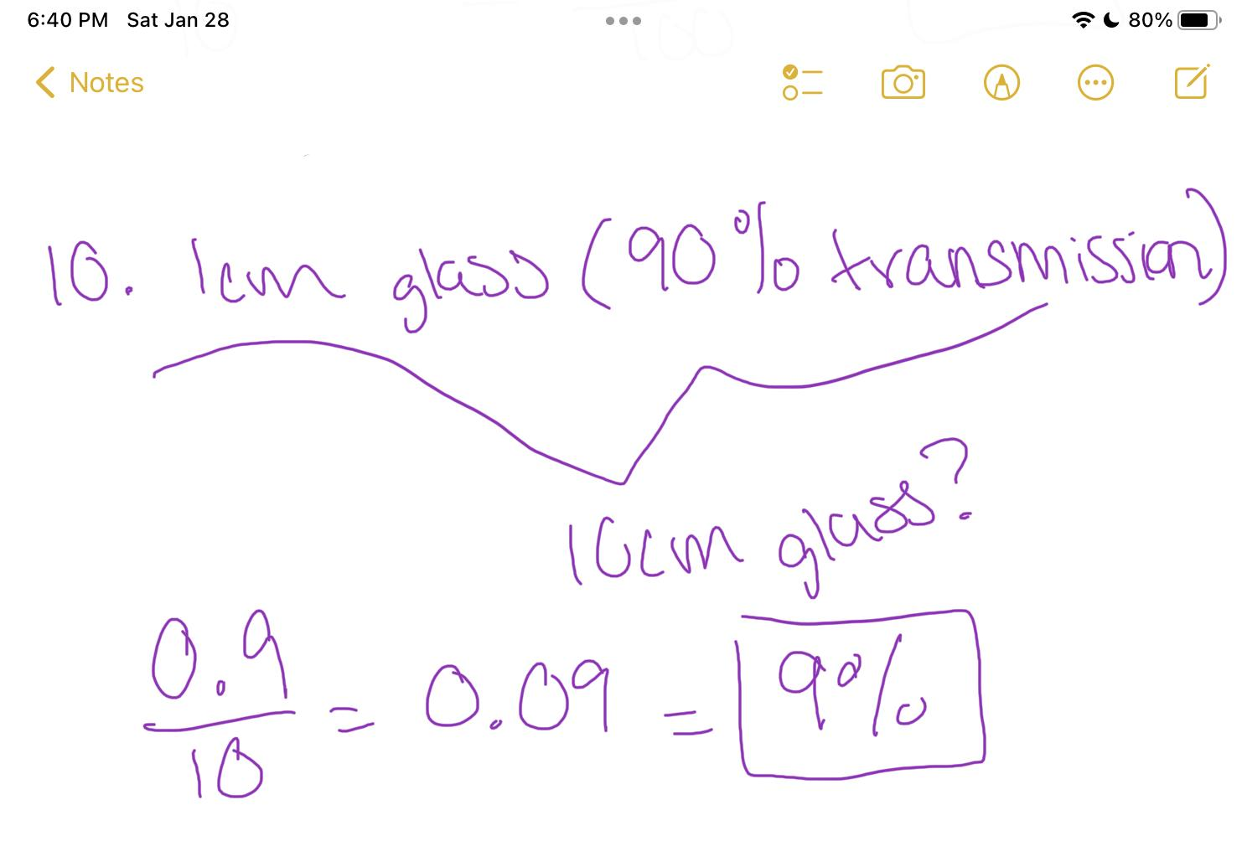
11. What happens to light that is scattered
in an optical fiber?
- It escapes from the sides of the fiber
- Glass atoms absorb its energy
- Glass atoms store the light and release it later
- It’s reflected back towards the light source
- It excites acoustic waves in the glass
12. What effect does dispersion have?
- Scattering of light out the sides of fiber
- Stretching of signal pulses that increases with distance
- Shrinking of signal pulses that become shorter with distance
- Attenuation of signal pulses

